Analyze Larry Summars’ Predictions

Yinglong(Jack) Zheng
1007931277

University of Toronto Scarborough
1265 Military Trail, Scarborough, ON
July 25, 2024

ABSTRACT
In recent years, there has been considerable interest in examining inflation rates under various policy frameworks. Larry Summers, a prominent economist in the United States, he has made influential predictions about America's inflation rate. This paper evaluates the reliability of Summers' predictions and focus on the inflation rate change due to the different policies by using Philips Curve and DAD-DAS Model. For my own research result, some of the Summers’ predictions are reliable some of them are over idealized.

1 Introduction

Larry Summers made several inflation predictions from 2019 to 2021. In 2019, Larry Summers posited that the natural rate of unemployment in the U.S. was around 3.6 percent. In February 2021, he predicted that Joe Biden’s $1.9 trillion American Rescue Plan would lead the U.S. to a prolonged period of high inflation. Summers projected that the way to reduce inflation might necessitate five years of unemployment above 5% or shorter periods with even higher unemployment rates[1].
The Phillips curve can effectively analyze the relationship between the inflation rate and the unemployment rate[2]. The DAD-DAS framework can clearly analyze how the variables change influence inflation and output.
2 Summers Predictions
2.1 2019 Natural Unemployment rate Prediction
During 2019, the U.S. didn’t have any acceleration of inflation, which means that the $π_{2019}=π_{2018}$. By the Phillips curve, if the supply shock constant from 2018 to 2019 equal zero, then the unemployment rate would equal the natural unemployment rate which is 3.6% same as Summers posited[1][2]. In the period from 2018 to 2019, there was an extremely horrible pandemic, which was COVID-19. It was spread globally. During that time, lots of stores temporarily closed. At that time, the U.S. supply change should not be ignored, it should be a negative constant. Furthermore, in 2018 and 2019, there were some tax policies implemented. Those changes will affect the supply in the U.S. market. Summers assumed that the natural unemployment rate of 3.6% had become unreliable[1].

2.2 Increase Unemployment Rate Prediction
Assumption one: the supply shocks are caused by harmful pandemics, extreme weather, wars, etc. The parameter of supply shock is very small, and I assume that there won't be many shocks in the future that can affect supply, the $v=0$. Assumption two: the natural unemployment rate equals half of the sum of the last two years unemployment rate.
$$u_{t}^{n}=\frac{u_{t−1}+u_{t−2}}{2}$$

2.2.1 Summers 3 predictions
Summers predicted that in 2022, the U.S. needs a one-year unemployment rate equal to 10%, two years 7.5%, or five years 6% to control the inflation rate. To begin with, the one-year unemployment rate is equal to 10%. The inflation rate in 2022 is 6.5%[3], the central bank’s target inflation rate is 2%, as Summers posited $u_{2022}^{n}=5\%$[1].
$π_{2022}=π_{2021}−β_{2022}\left(u_{2022}−u_{2022}^{n}\right)$ (1)
$π_{2022}=7\%−β\left(10\%−5\%\right)$ (2)
While the target inflation rate of the central bank is 2%, assume that $π_{2022}=2\%$, we got $β_{2022}=0.82$ for Summers’ prediction that a one-year 10% unemployment rate can control the inflation rate. In real life, the natural unemployment rate is 1.5% lower than what Summers posited, after plugging in the $u_{2022}^{n}=3.5\%$ and $β_{2022}=0.82$, equation(2) yield $π_{2023}=1.17$, which is lower than the target inflation rate.
Moreover, in Summers’ prediction, with a two-year unemployment rate of 7.5%, inflation in 2024 should be 2%, assume that in 2023 and 2024 the supply shocks are irrespective [1].
 | $$u^{n}$$ | $$u$$
2022 | 5% | 7.5%
2023 | 6.25% | 7.5%
$π_{2022}=6.5\%−0.82\left(7.5\%−5\%\right)$ (3)
$$π_{2022}=4.45\%$$
$π_{2023}=4.45\%−β_{2023}\left(7.5\%−6.25\%\right)$ (4)
To let $π_{2023}=2\%$, $β_{2023}=1.96$. Bring $u_{2022}^{n}=3.5\%$ and $u_{2023}^{n}=5.5\%$ back to equation(3) and(4), the $π_{2023}= −0.7$ which is much lower than the target inflation rate of central bank.
Furthermore, the five-year unemployment rate is higher than 6%, which implies that in 2026 the inflation rate should be 2%[1]. Besides, assume that there is no significant supply shock from 2022 to 2026.
 | $$u^{n}$$ | $$u$$
2022 | 5% | 6%
2023 | 5.5% | 6%
2024 | 6% | 6%
2025 | 6% | 6%
2026 | 6% | 6%
Form 2025 $β\left(u−u^{n}\right)=0$, so that the inflation rates in the following years within the time period should equal to 2024.
$$π_{2023}=6.5\%−0.82\left(6\%−5\%\right)$$
$$π_{2023}=5.68\%$$
$$π_{2024}=5.68\%−1.96\left(6\%−5.5\%\right)$$
$$π_{2024}=4.7\%$$
Intuitively, those three predictions have all failed. In the reports of the Phillips curve’s slope, they estimated that $β=0.006 to 0.01$[4] and $β=0.002 to 0.005$[5]. Regardless of how much beta equals, the slope is too small that the curve is really flat. Thus change in inflation caused by multiplying the cyclical unemployment rate by this parameter is negligible. The data demonstrates that it is not feasible to control inflation directly by raising the unemployment rate.

2.2.2 DAD-DAS Framework for control inflation
To influence inflation through shifts in the DAD curve, it is necessary to alter the exogenous variables, for example, demand shock. There are many ways to change the parameter of demand shock. Since we want to decrease the inflation rate, we could use contractionary fiscal policy and contractionary monetary policy. For example, the central bank could increase the basic point of the interest rate, there will have a negative demand shock due to the policy. Those shocks can decrease $ε_{t}$, thus the DAD curve shifts down to DAD₁ and then the DAS curve shifts along to DAS₁. The changes show in Figure 1.
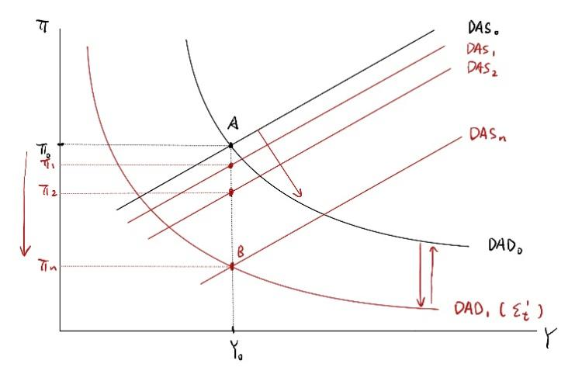 Figure 1
Although the shocks are temporary, after the DAD curve shifts back to its original place, the DAS curve will shift back step by step. Moreover, even though the curves will shift back, the government can try some new policies to influence the inflation rate.
2.3 American Rescue Plan Prediction
Summers also predicted the inflation change due to Joe Biden’s $1.9 trillion American Rescue Plan[1]. This plan gives U.S. citizens direct payments, extends the duration of unemployment benefits, and provides some other support for public health and small businesses. President Biden wants to stimulate consumption to recover the damage of COVID-19 to the U.S. economy[6]. This is an expansionary fiscal policy; by applying the DAD-DAS model, the increase will lead to DAD shifting right and DAS shifting along.

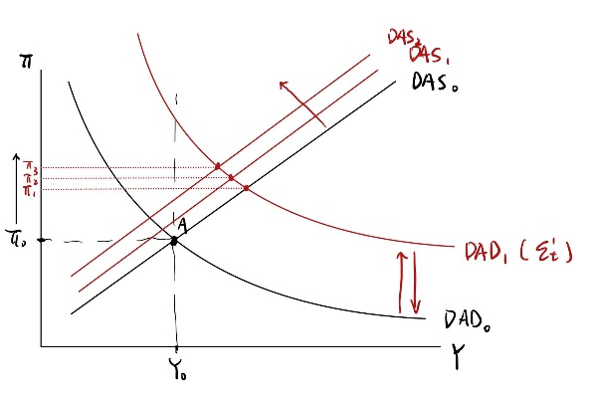Figure 2
Assume that there are no more government policies that can change the economy, the change in $ε_{t}$ is temporarily. During the plan, the expected inflation increased, and the DAS shifted further and further. When the plan ends, the DAD will decrease back to the original; this shock will lead DAD to shift back to the original; the expected inflation-increasing effect is less than the demand shock-decreasing effect; DAS will shift right slowly until it returns to the original place. This model reasonably authenticates Summers' prediction that the persistent hyperinflation he describes is indeed realistic.

3 Conclusion
In conclusion, the paper evaluates the predictions of inflation rate from Larry Summers. His assumptions during the COVID-19 pandemic revealed limitations of natural unemployment rate and ignored supply shocks. The analysis demonstrates that the unemployment rate change can not effectively control the inflation rate to the target. According to the DAD-DAS framework, government could try some contractionary fiscal policy or contractionary monetary policy to control the inflation rate. While Summers accurately identified the influence on inflation rate that affect by American Rescue Plan, the DAD-DAS model clearly analyzed that how expansionary fiscal policy will influence the inflation rate.

4 References
[1] E. Levitz, “Larry Summers was wrong about inflation,” Intelligencer, https://nymag.com/intelligencer/2023/06/larry-summers-was-wrong-about-inflation.html

[2] Gregory Mankiw and William Scarth, Macroeconomics 5nd Canadian Edition, Worth Publishing, 2015.

[3]“Current US inflation rates: 2000-2024,” US Inflation Calculator | Easily calculate how the buying power of the U.S. dollar has changed from 1913 to 2023. Get inflation rates and U.S. inflation news., https://www.usinflationcalculator.com/inflation/current-inflation-rates/

[4] Hazell, J., Herreno, J., Nakamura, E., & Steinsson, J.B. (2020). The Slope of the Phillips Curve: Evidence from U.S. States. NBER Working Paper Series. https://www.nber.org/system/files/working_papers/w28005/w28005.pdf

[5] J. Hazell, J. Herre&ntilde;o, E. Nakamura, and J. Steinsson, “The slope of the Phillips Curve: Evidence from U.S. states*,” OUP Academic, https://academic.oup.com/qje/article/137/3/1299/6529257

[6] “American Rescue Plan,” The White House, https://www.whitehouse.gov/american-rescue-plan/

